* Let’s understand the basic process of Version Control with git.
* Create a directory and some files and directories into it 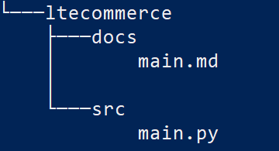
* We need to add version control capabilities to this directory. In Git if we need a version control, we need to have a repository.
* So, to make this directory structure a repository (local repository) we need to initialize using git init 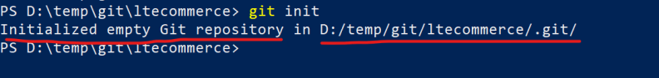
* Lets add the changes from working tree to staging area by using add comand 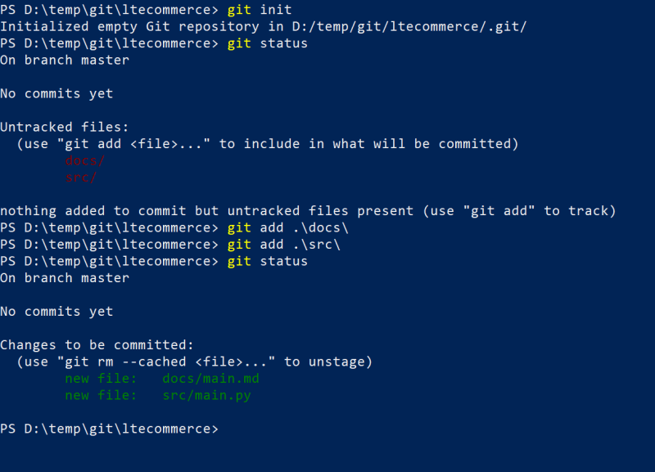
* Since commit requires username and email lets try to configure the username and email (This is one-time activity)

git config --global user.name 'devops'

git config --global user.email 'qtdevops@gmail.com'

* Now lets commit the changes from staged area to local repository 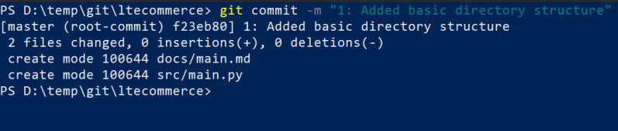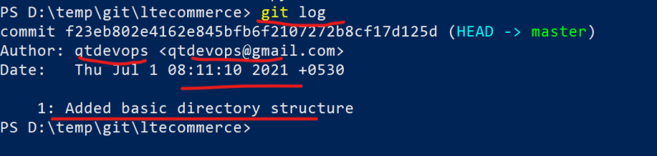
* The above process can be summarized as shown below 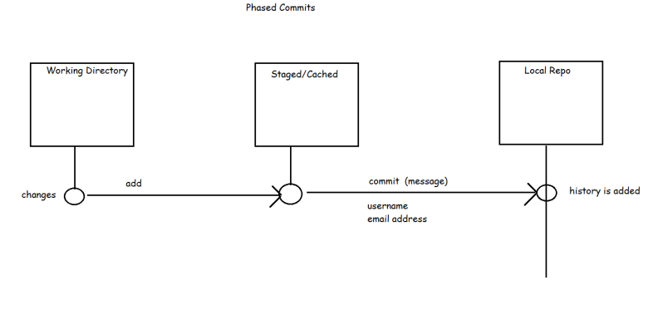
* Let’s add some more changes as second commit 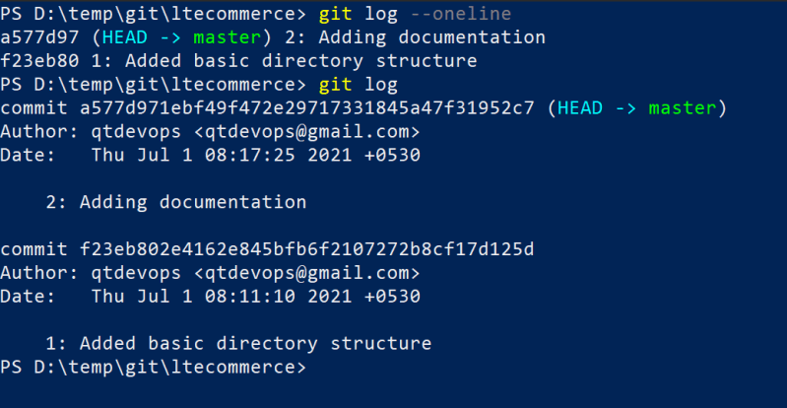
* Quick commands to explore git init, git status, git add, git commit and git log